Agents in Langchain
02.07.2025

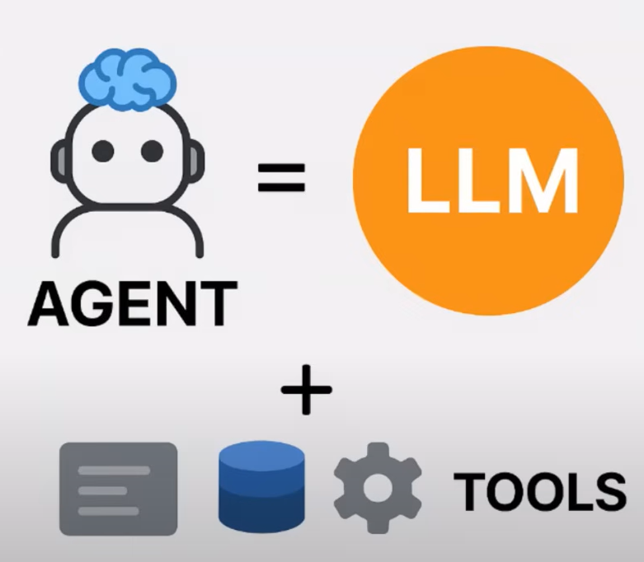
Agents
An AI agent is an intelligent system that receives a high-level goal from a user and autonomously plans , decides , and executes a sequence of actions by using external tools.
While maintaining context ,
Reasoning over multiple steps ,
Adaptive to new information ,
And optimize the intended outcome.

React :
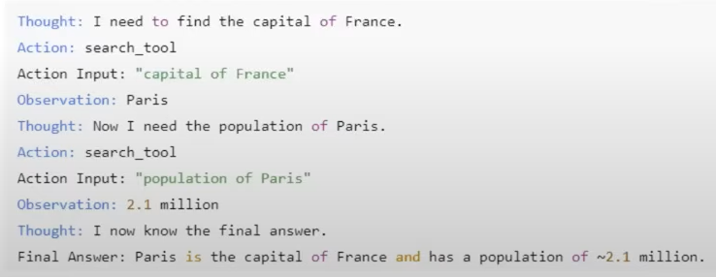
A design pattern used in AI agents that stands for Reasoning + Acting . It allows a LLM to interleave internal reasoning and external actions in a structured, multi- step process.

Agent and Agent Executor :
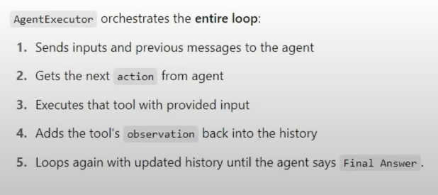
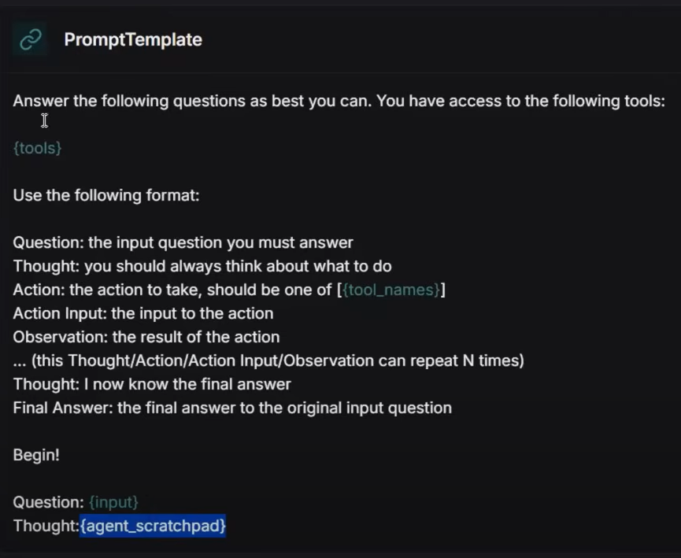
Agent
Agent Executor
Search tool
Thought_trace { }
user_query
Action
Action_tool
Thought
Action
Observation
Agent Executor starts the loop
It calculates output using the tool

ReAct offers this type of Prompt template which again and again goes into the loop with query and updated thought.

